

**E-Commerce Website**

**Software Design Document**

– Hanoi, September 2021 –

Demo Product: [JSP - Servlet - JDBC – SQL Server] – Git

Home Page (before login):

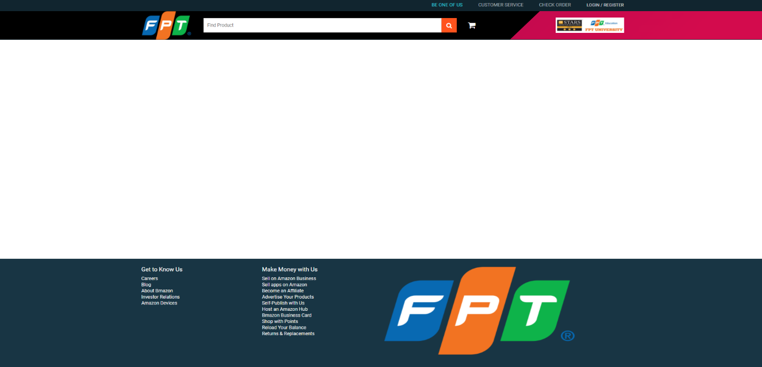

Home page (after login):

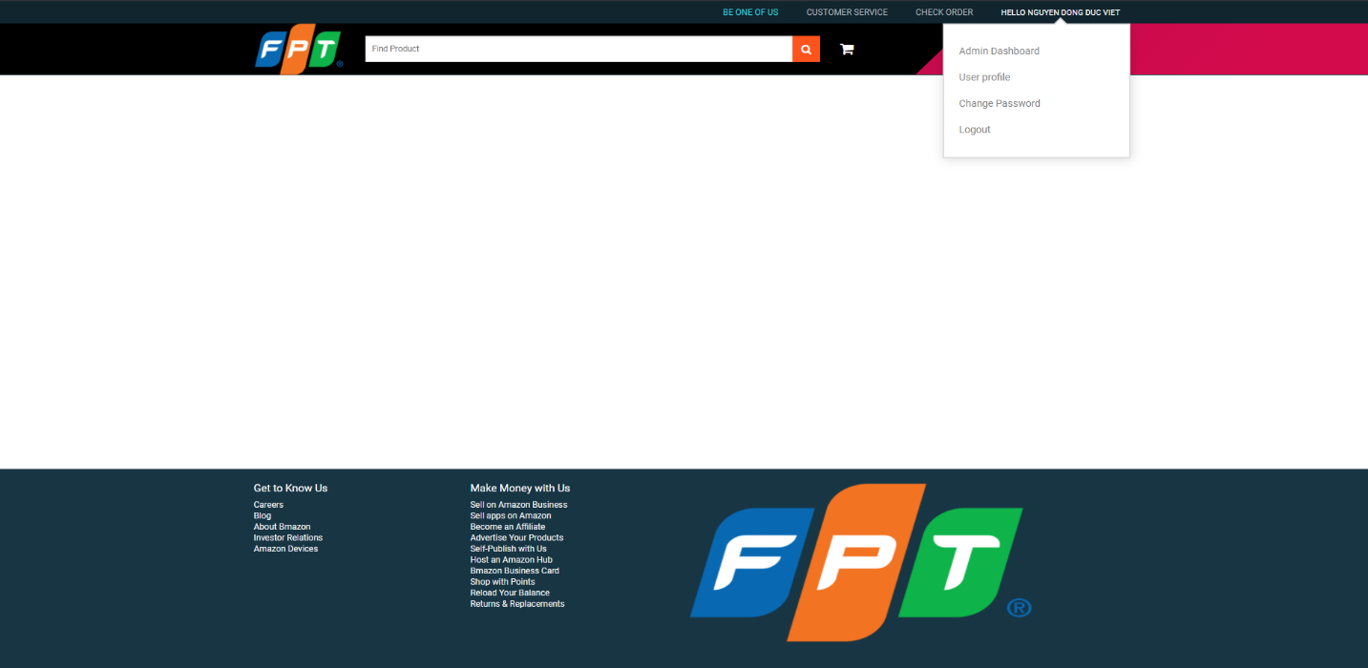

Sign in Screen:

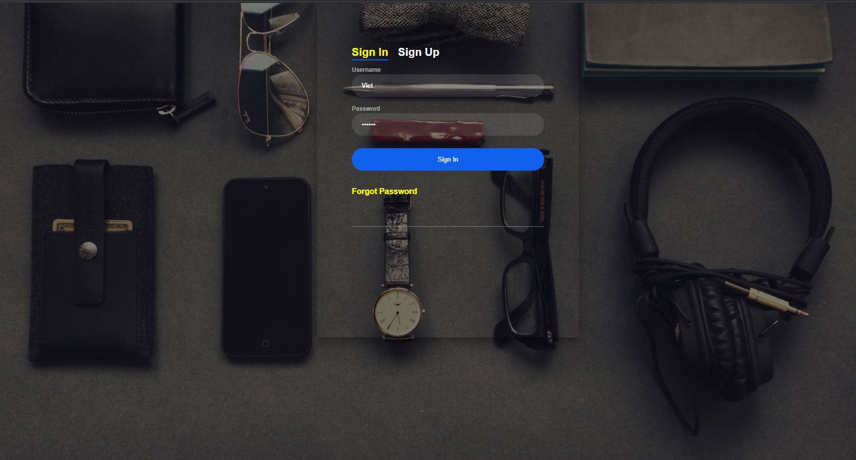

Sign up Screen:

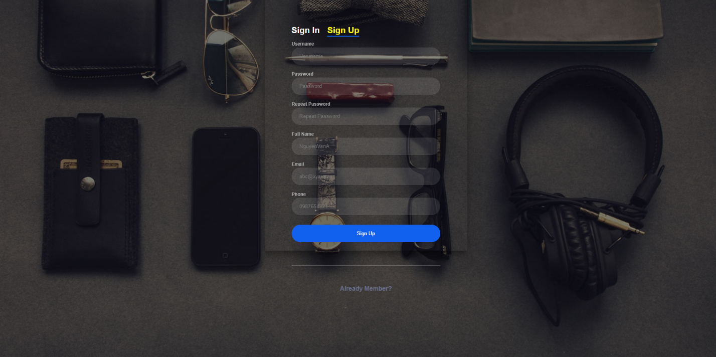

User Profile Screen:

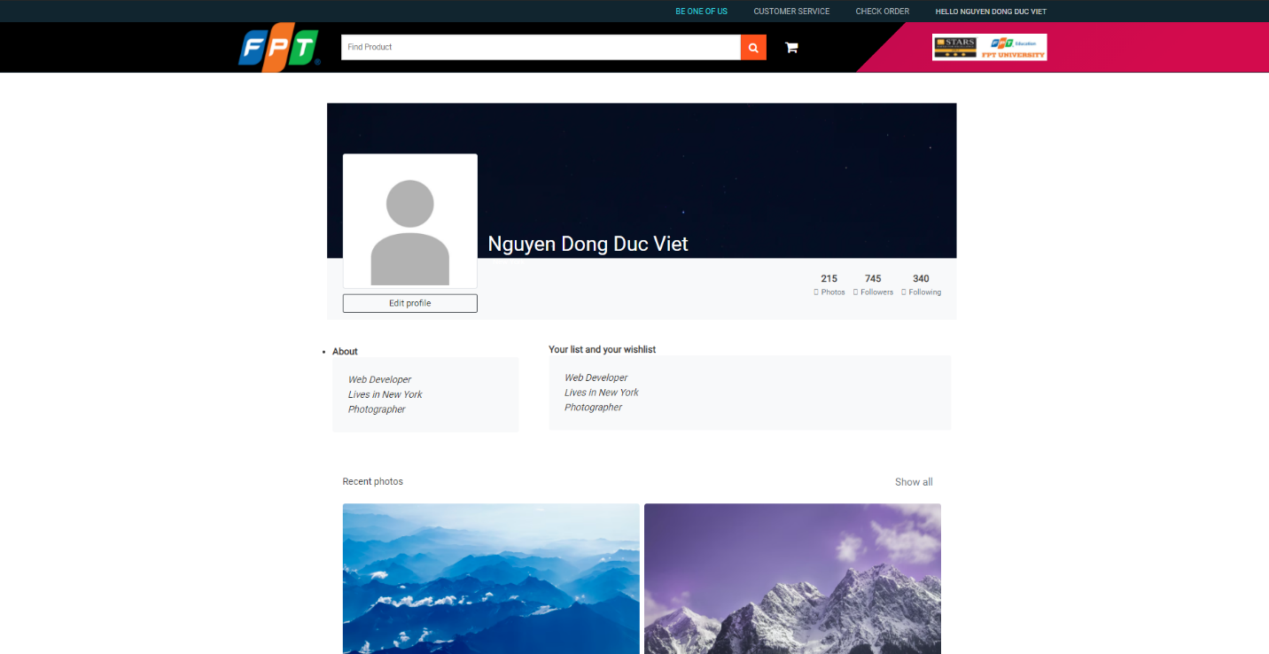

Admin Dashboard Screen:

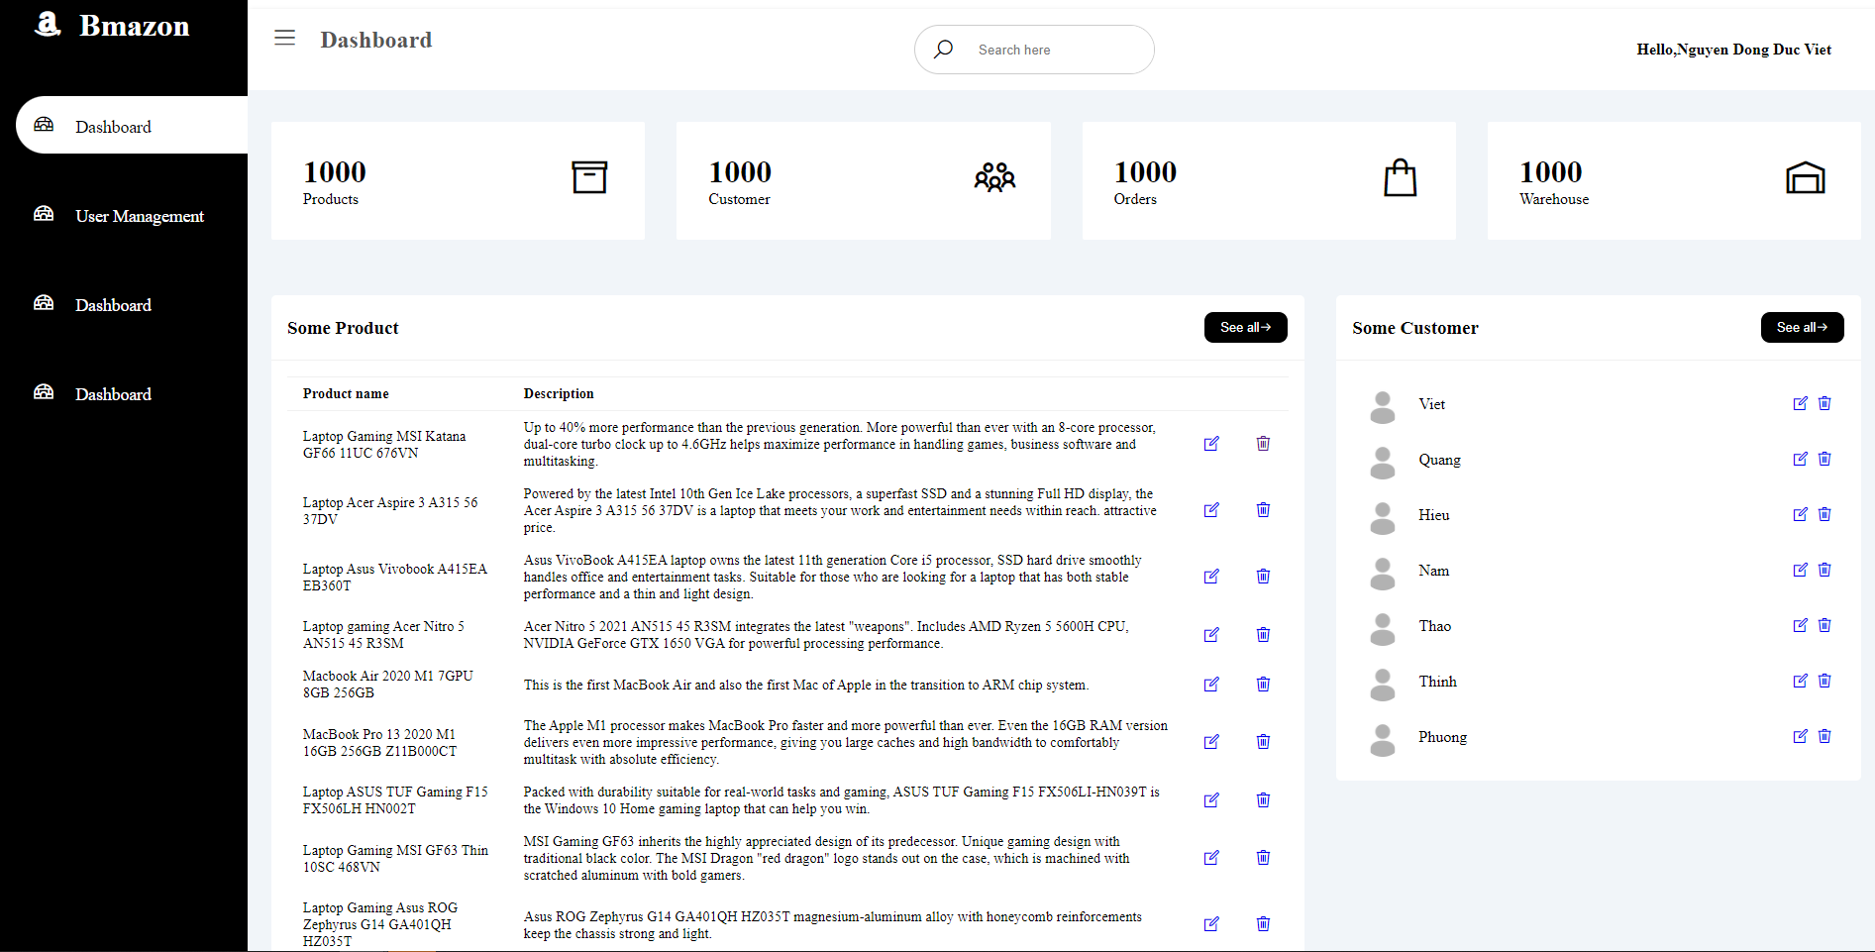

User Management Screen:

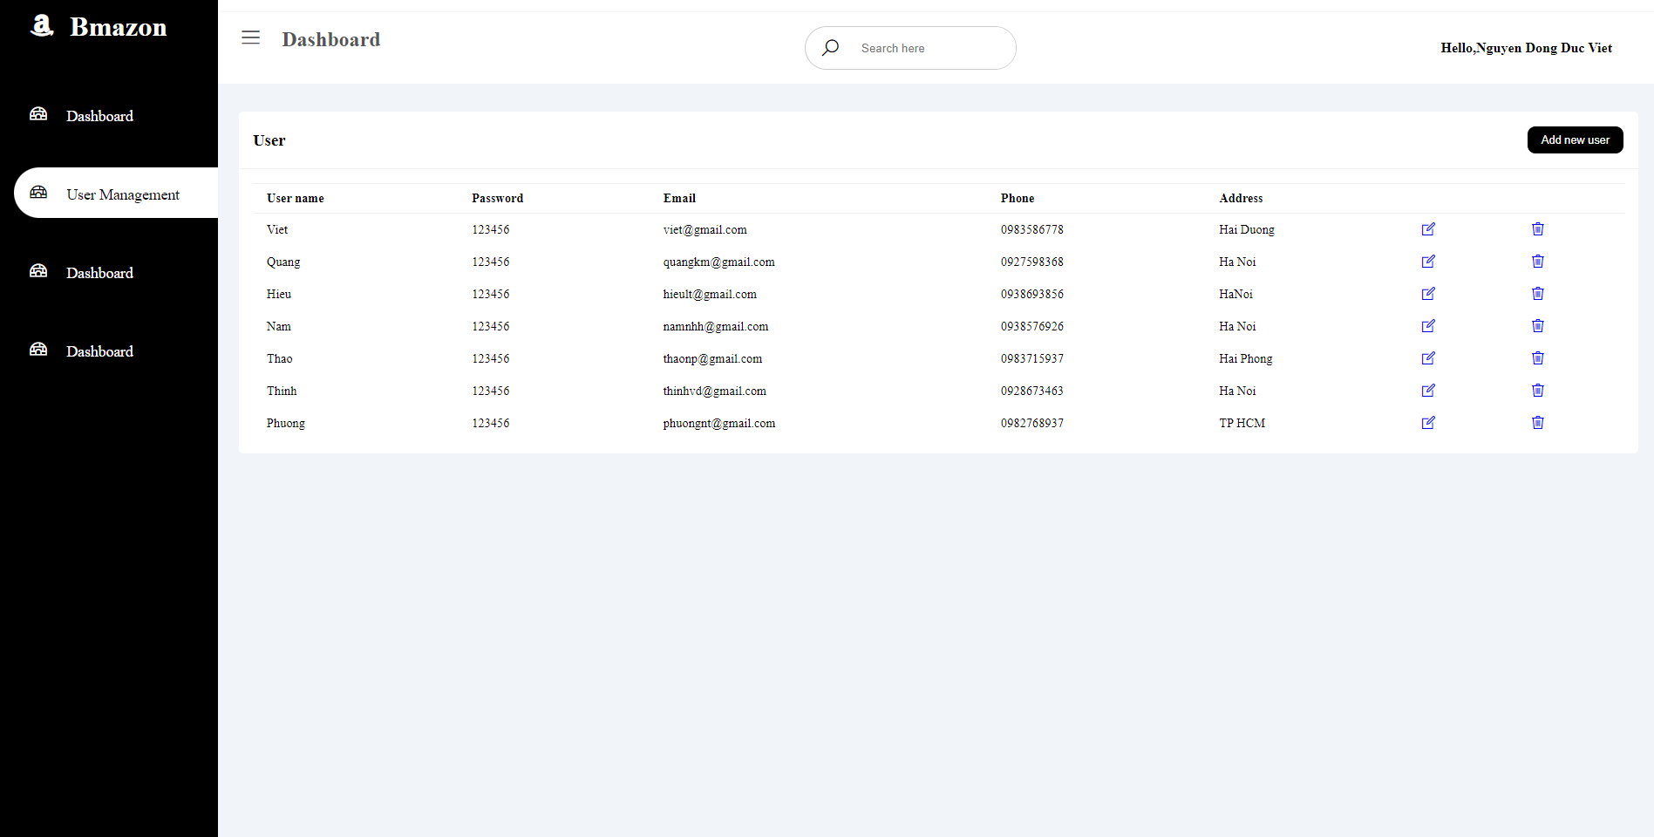

[Source Code]: https://drive.google.com/file/d/1Bpo_LeEE9h7lWiJSk47JPD-fBRZ4p57d/view?usp=sharing